**Final Design Document**

WNR

Stephen Xia, Tingkai Liu, Yuan Gao, Xin Huang

1. **Introduction**

WNR is producing a new ECoG (a.k.a. Intracranial EEG) electrode that incorporates wireless connectivity via Bluetooth Low Energy between each individual intracranial electrode probe and a central recording terminal. Each electrode will be attached to a low-power analog to digital unit that will read and transmit neural data to a bluetooth microprocessor to transmit wirelessly in real-time to a receiver. An array of up to 16 wireless electrodes should be able to transmit simultaneously to a single recording receiver. From the receiver, medical professionals can access the data in real-time and analyze the captured data to best treat the patient. Our embedded system seeks to untether the patients and give them their mobility and their life back.

The creation of the WNR system requires extensive knowledge in Electrical and Computer Engineering concepts as well as the use of various software and hardware tools.

Required Hardware Test Tools:

* Digital Oscilloscope
* Power Supply
* Function Generator
* Digital Multimeter

Required Software:

* Nordic NRF52 SDK
* Nordic NrfGo Studio
* Nordic Master Control Panel
* Keil UVision 5 IDE
* Eagle PCB
* Solidworks CAD
* Gnu Compiler Collection (GCC)

Required Hardware Components:

* Nordic NRF52 chips
* Nordic NRF52 Development kits
* Intan RHD2132 32 A2D channel amplifier chip
* Texas Instruments SN65LVDT41 LVDS chip
* Intan C3410 RHD2000 electrode adapter board for 36-pin connector
* Zinc Air P13 batteries
* MicroUSB Cables

Note that prototyping and testing the WNR system with the NRF52 development kit will require an (Low-Voltage Differential Signaling) LVDS chip to read neural signals from the Intan chip. But the completed alpha production system will not need the LVDS chip and will communicate over SPI from the Intan A2D chip to the NRF 52 Chip.

1. **System Breakdown**

The brain signal that is fed into the system undergoes the following processes:

1. Amplified and converted to digital data by Analog-Front-End (RHD2132)
2. Compressed by nRF52 chip which integrates transmitter and microprocessor
3. Transmitted wirelessly by nRF52 over Bluetooth Low Energy protocol
4. Received by a central nRF52 which is connected to a terminal
5. Decompressed on the terminal

The system can be visualized as follow:

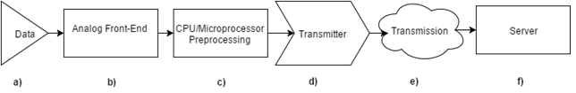

Figure 1. WNR System Breakdown

The involved components are discussed below:

**Analog Front End**

The analog signal generated by the brain and picked up by the electrodes go through the process of amplification and then Analog-to-Digital-Conversion (ADC). These two processes combined are termed the analog-front-end (AFE).

The amplification is important because brain signals have amplitudes on the of 100 uVpp (micro volt peak-to-peak) to 1 mVpp (millivolt peak-to-peak). To minimize the ADC error, the analog signal is first passed through a good amplifier which has a very low cut-off frequency (~0.01Hz) before being converted to a digital signal.

The amplification and ADC processes are integrated and implemented by the RHD2000 series of Intan TechnologiesTM. Our current choice of AFE chip is RHD2132, which offers 32 analog input channels. Because the current status quo of number of contacts points of a single ECoG electrode is ~16, 32 will give us sufficient margin for future improvement.

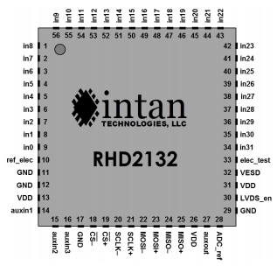

Figure 2. Intan Technologies RHD2132 Chip pinout

For development, Intan offers amplifier board which have RHD2132 chip soldered onto a custom PCB. This amplifier board, as mentioned, requires an additional LVDS component to communicate to. However, the LVDS converter will not be necessary in the final design as we will opt for a much less power-consuming standard CMOS signaling.

The RHD2132 communicates using standard Serial Peripheral Interface Bus (SPI) protocol. To program the chip, corresponding SPI pins on the RHD2132 chip are connected to the SPI pins on our microcontroller - nRF52. The RHD2132 chip is thus programmed through nRF52. Detail instructions of SPI commands built into RHD2132 can be found in its datasheet.

The functionality of the Intan RHD2132 has been verified as follow:

1. 6mVpp 10Hz Sine wave is generated by a function generator
2. The sine wave output is fed into RHD2132 analog input channel
3. The digital signal after amplification and ADC is transmitted to the computer over UART
4. The resulting signal is compared against the original signal

The spectrum of the digital data recorded by the Intan RHD2132 is plotted as follow:

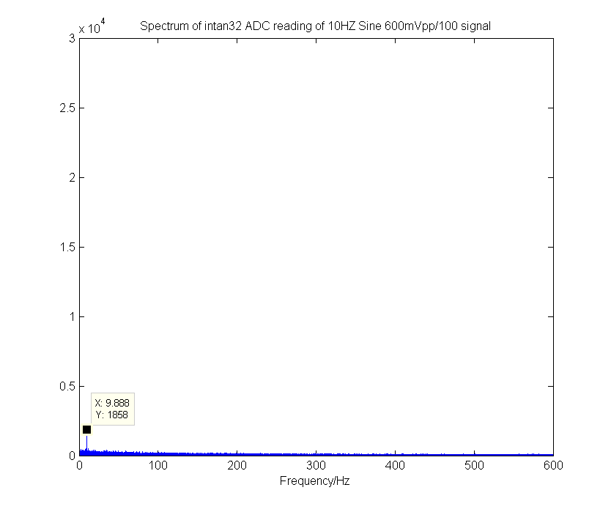

Figure 3. Spectrum of digital signal converted from 10Hz 6mVpp sine wave

From the spectrum we can clearly see a peak at 10Hz, corresponding to the frequency of the input sine wave. This verifies the functionality of the analog-front-end chip RHD2132.

**Compression**

Data compression is important to the application because the Bluetooth Low Energy (BLE) protocol, although consumes very little power, has rather strict throughput restrictions. As such, it is difficult to transmit all the digital signals without performing some form of preprocessing (Compression).

The final design of WNR uses an ultra-lightweight compression algorithm called Heatshrink. This compression algorithm is developed based on a lossless compression algorithm called Lempel–Ziv–Storer–Szymanski (LZSS). This compression algorithm is particularly suitable for embedded purposes because of its small size.

To use this compression algorithm, we ported existing library files into the nRF52 chip. The compression algorithm is ran after a pre-initialized 8 kBytes data buffer is populated with 8-bit ADC data that is obtained from the AFE. The data after compression is passed to the wireless transmission module to be sent to the terminal.

The compression is implemented with the buffer manager. The buffer manager contains 16 buffers for corresponding channels. When the buffer manager is populated with converted digital data, it automatically compress the data and call the sending handler to send the data over bluetooth low energy communication protocol. If the buffer is full during compression, it will flush the existing data and take the compressed data from the breaking point.

The data compression rate has been tested on actual patient data, and the compression ratios are presented as follow:

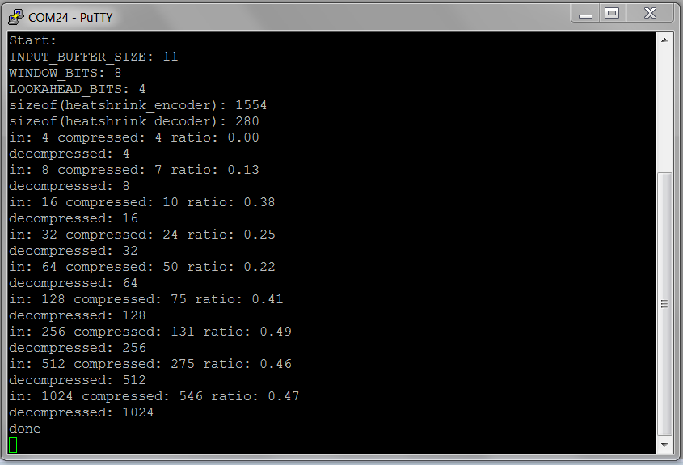

Figure 4. Compression ratio of Heatshrink on real patient data.

in - input data length in Bytes; compressed - compressed length in bytes; ratio - compression ratio

We found through empirical data that the optimized tradeoff point with efficiency and space is 8kB, where the compression ratio is 0.501. This is equivalent to the amount of data generated in 0.5 seconds on a single probe.

**Bluetooth Low Energy(BLE) Wireless Transmission**

nRF52 has a BLE component on-chip. Thus, creating wireless transmission functionalities entails programing nRF52.

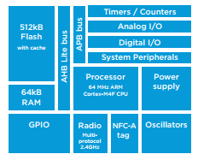

Figure 5. Integrated Systems on NRF52 SoC

For the purpose of this project, we need to establish a 1-to-many communication scheme with multiple peripheral chips (chips that collect brain signal) to a central chip (chip that interfaces with terminal where data from all peripheral chips can be accessed remotely).

To maximize throughput and minimize BLE overhead, a custom BLE service is created based on Nordic’s Nordic UART Service (NUS). Each peripheral chip is to be programmed to place data after compression into a data structure that uses this BLE service. The peripheral chips are programed advertise using NUS UUID. Once the peripheral is discovered by a central and connection established, the peripheral will begin sending compressed data to the central device.

The central place a key role in communicating with multiple peripherals. Because all the peripherals are sharing the same BLE service, the central simply needs to create an array of connection handles to keep track of the peripheral devices that are connected to it. The central will then switch between peripheral devices and request for compressed data to be sent to the central regularly from all devices.

To put things in perspective, the WNR system consists of a receiver or terminal, such as a computer or phone application, that will request connection with up to 16 independent electrodes. Each electrode will have the capability of sending the data it samples from the brain to the receiver application using its wireless BLE module. The receiver application will then be able to display the data received in real-time or manipulate the data for other applications. In BLE terminology, the receiver application will be the single central device in the system, and the electrodes will all be acting as peripheral devices. This conveniently forms a star topology, where connections are only between the central and one of the peripheral devices; peripheral devices do not communicate with each other. This topology is one of the simplest topologies to work with because data transfer is in one direction, from peripheral to central, and it maximizes throughput from central to peripheral devices without requiring any type of complicated communication protocol. The following figure shows an example of a network that operates in a star topology.

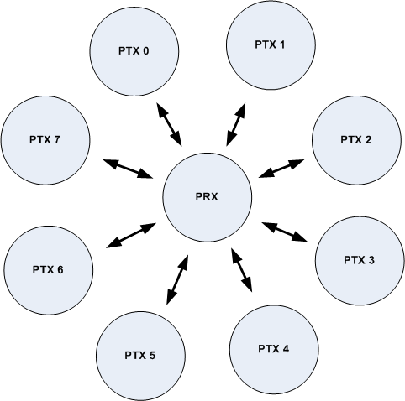

Figure 6. Example of a star topology; PRX is the central device and the PTX devices are peripherals

The received data is then decompressed by the central device and fed back to terminal (a PC) using [Universal asynchronous receiver/transmitter](https://en.wikipedia.org/wiki/Universal_asynchronous_receiver/transmitter) (UART) protocol over USB. The terminal application then has its own discretion as to what it does with the data. The terminal data could do, but is not limited to, the following: plot the data in real-time, transform the data (such as taking a fast Fourier transform) for other applications, and analysis.

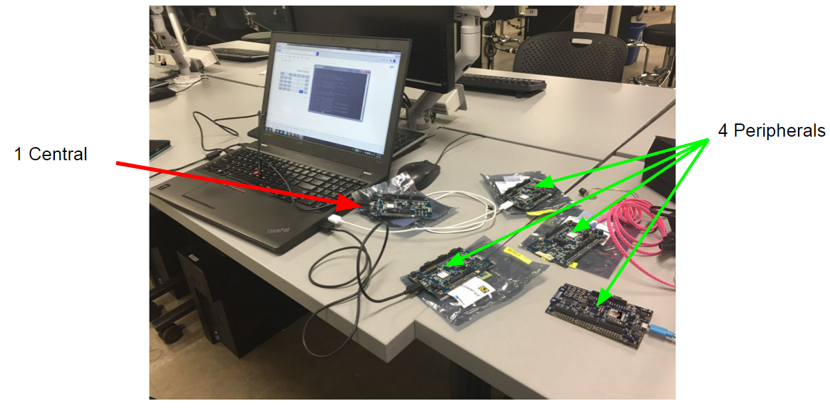

Figure 7. Setup of one-to-many(4 peripherals to 1 central) communication testing

**Power Systems**

The power system of the WNR system is pretty straight forward. The device is only powered via non-rechargeable batteries. The batteries selected must fit within the size requirements of 8mm diameter and ideally 4mm in height to allow for the rest of the system components to fit within the ideal desired 10mm height.

Currently, the WNR system is using off-the-shelf hearing aid device batteries. The medical grade batteries are utilizing zinc-air technology which allows for compact, lightweight power transmission to the rest of the WNR system. Our choice of Zinc Air P13 batteries are able to provide 310mAh at 1.45 V in just a 7.9mm diameter by 5.4mm height, weighing just 0.83g. However, the 1.45V is not enough voltage to power all the components in our system as our chips work at an ideal voltage of 3V. We will be using 2 Zinc Air P13 batteries in series to provide 2.9V at 310mAh, which will be sufficient enough to power our system for at least 24 hours. The batteries therefore will be stacked on top of each other and placed onto the negative battery pad and secured by the positive battery screw cap.

We have measured and calculated the total power draw of the WNR system to be 169mAh for a 24 period operating period, which is well under the capacity of our P13 Zinc Air battery setup. The Intan A2D chip takes 22mAh to run for 24 hours, while the BLE transmission is the heaviest current consumer at 147mAh for 24 hours.

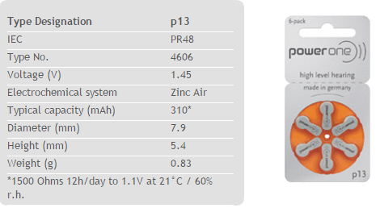

Figure 8. Zinc Air P13 Battery Specifications

Ideally, the battery technology will be updated before going into mass production with a custom higher density lithium ion battery providing more than 500mAh at 3V, which will provide us with battery life lasting about 3 days., which will help make the system more convenient such that the batteries do not need to be replaced everyday.

**WNR System Housing**

The final design of the alpha version of WNR system will be enclosed in an 3D printed enclosure cap measuring 8.5mm in diameter by 12mm in height. Inside the cap will be the PCB containing all of the WNR system’s necessary components such as electrode inputs, A2D chip, Bluetooth Low Energy chip, and battery. The components will each exist on its own layer of PCB and manually connected via jumpers to each other layer. The electrode inputs will exist on the bottom layer of the PCB along with the A2D chip. The next layer will be the bluetooth chip layer. Finally the last layer will be the negative battery interface pad. These 3 PCB layers are to be printed and milled by a PCB machine and cut into a 8mm diameter circle. The 3 layers will be connected by jumpers and inserted into the 3D printer enclosure cap and topped off with positive battery connector screw cap. The bottom of the cap allows for the electrode needle probe pins to connect to the first layer of PCB with the electrode input holes.

For the mass production of the WNR system, the WNR system will be enclosed in an IP68 medical grade aluminum cap containing the PCBs with A2D and Bluetooth Low Energy chips. This will ensure the device is dust and waterproof for submersion in water past 1m. The PCBs will also be professionally printed on a multilayer PCB without the need for jumper connectors and will allow for a lower total stacked height. The layered PCB will be inserted into the milled aluminum cap and topped off with an aluminum battery connector screw cap.

1. **Conclusion**

The WNR system is comprised of the following subsystems shown in the figure 1.

To recapitulate the system’s operation, the brain signal that is fed into the system undergoes the following processes:

1. Amplified and converted to digital data by Analog-Front-End component
2. Compressed by nRF52 chip which integrates transmitter and microprocessor
3. Transmitted wirelessly by nRF52 over Bluetooth Low Energy protocol
4. Received by a central nRF52 which is connected to a terminal
5. Decompressed on the terminal